Lab 4-1: Replacing the Shell with a Custom Full Screen Browser Based UI
After completing this lab, you will be able to:
Objectives
- Replace the Windows CE shell with a custom HTML based shell
- Clone a feature from the PUBLIC folder

Before working on this lab, you must have:
Prerequisites
- Understanding of Windows CE components and modules
- Understanding of basic Windows CE build process

Lab Setup
Estimated time to complete this lab: 60 minutes

To complete this lab, you must have:
- A development workstation running Windows XP or Windows 2000
- Platform Builder 5.0 installed

Exercise 1
Create MyIA Platform
In this exercise you will use the New Platform Wizard to create a new platform to be used in subsequent exercises.
Create a new platform Workspace
    - Close Platform Builder if it is open disconnecting from the emulator if connected and saving any changes.
    - On the development workstation, open the Platform Builder application.
On Start Menu (press Windows key or click Start on the Taskbar), select All Programs, then select Microsoft Windows CE 5.0, and then select Platform Builder.
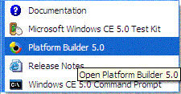
(there may also be a shortcut on the desktop)
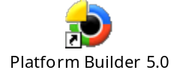
    - On the Platform Builder File menu, click New Platform to launch the New Platform Wizard:
    - Click Next.. The New Platform Wizard will prompt you for the name and location of the new Workspace being created. Enter the Name MyIA and click Next.
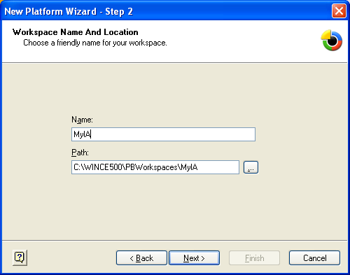
    - New Platform Wizard will prompt you for your platform BSP from the list of available BSPs.
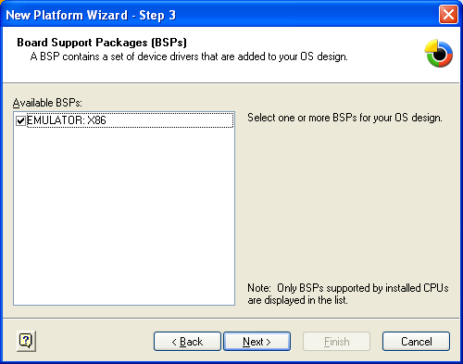
    - Select EMULATOR:X86 and click Next.
    - New Platform Wizard will prompt you to select your design template from the available list of Design Templates:
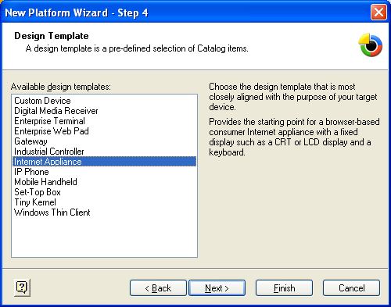
    - Select Internet Appliance and click Finish.
    - Click Finish to confirm Step 7.
    - On the toolbar, select Emulator: x86_Debug for the active configuration.
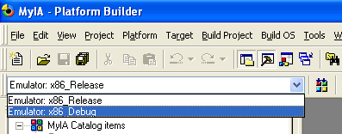
    - Build the Image by selecting Build OS and then Sysgen, or by clicking the Sysgen button on the toolbar. This may take up to 20 minutes to complete.
    - While the OS image is building, configure the connectivity options by selecting Target and then Connectivity Options… from the menu.
    - Select Add Device, enter the New Target Device Name as My IA Emulator, and click Add.
    - In the Target Device Connectivity Options dialog select Emulator for both Download and Transport.
    - Click on the Download Settings button, and setup the screen size to 640x480 and Ethernet support to the appropriate Virtual Switch.
    - Click OK to confirm the changes, and then Apply in the Target Device Connectivity Options dialog.
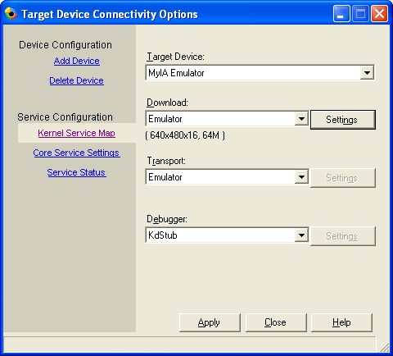
    - Close the Target Device Connectivity Options dialog.
    - Wait for build to complete.
    - Once the build has finished, select Target and then Attach Device to download the image to the emulator. You should see the following:
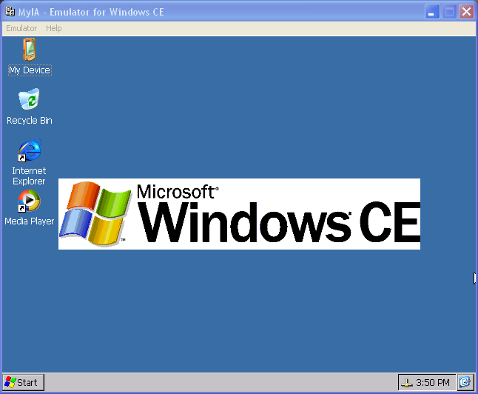

Exercise 2
Clone IESIMPLE

In this exercise you will, clone the IESIMPLE sample application and add it to the MyIA platform.

This exercise manually clones the IESIMPLE sample from the public folder. CE 5.0 has a cloning feature that allows items that can be added to the OS design to be cloned. Unfortunately IESIMPLE cannot be added to the OS design, so we must do the clone manually.
Note

Clone IESIMPLE
    - Disconnect Platform Builder from the emulator by selecting Target and then Detach Device from the menu.
    - Create an empty project by selecting File and then New Project or File… from the menu.
    - The New Project or File dialog will prompt you for the type and name of the new project.
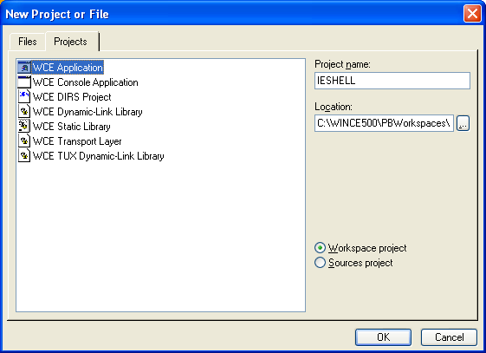
  - Select WCE Application.
  - Enter the Project name as IESHELL.
  - Click OK.
    - Enter IESHELL for the Feature name. Fill in the other field or not as you see fit, and click Next.
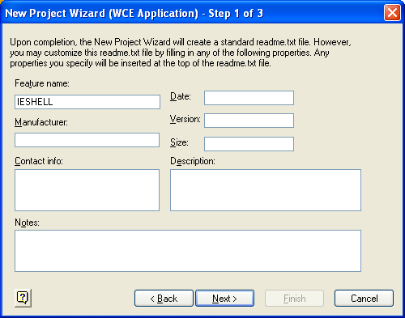
    - Select An empty project and click Finish.
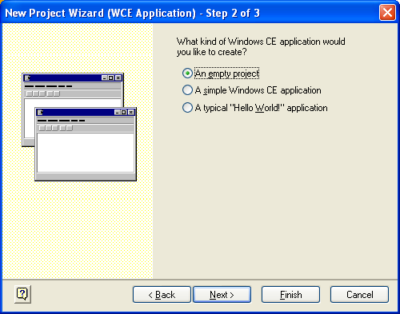

    - Using File Explorer, copy the .cpp, .h and .rc files (ONLY these files) in WINCE500\PUBLIC\IE\OAK\IESIMPLE to the newly created project directory - WINCE500\PBWorkspaces\MyIA\IESHELL.
    - Rename iesimple.rc to ieshell.rc in the new IESHELL directory.
    - Add the newly copied files to the IESHELL project. In Platform Builder select the File View and expand the Projects Branch.
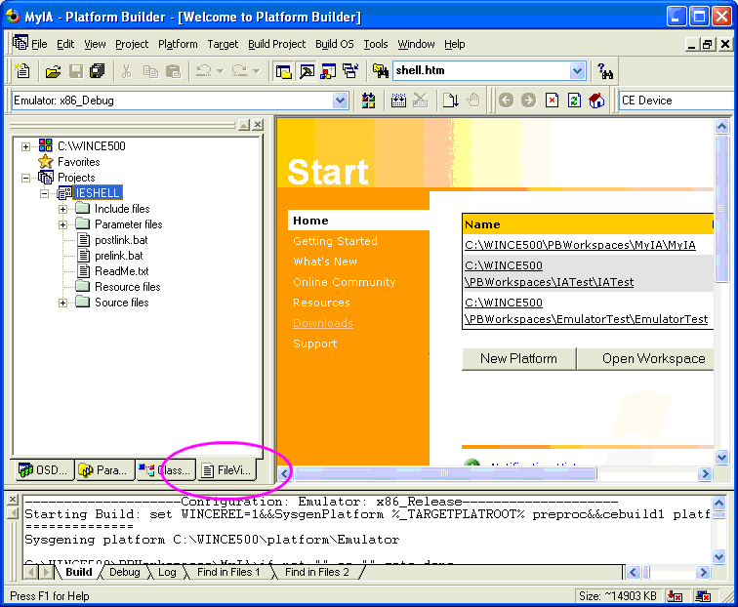

  - Right click on Source Files branch and select Add Files…
  - Add mainwnd.cpp.
  - Right click on the Include Files branch and select Add Files…
  - Add mainwnd.h and resource.h.
  - Right click on the Resource Files branch and select Add Files…
  - Add ieshell.rc.
    - Open the SOURCES editor by either:
  - Selecting IESHELL, followed by the Project and then Settings… menu item, or
  - Right clicking on IESHELL and selecting Settings… from the pop-up menu.
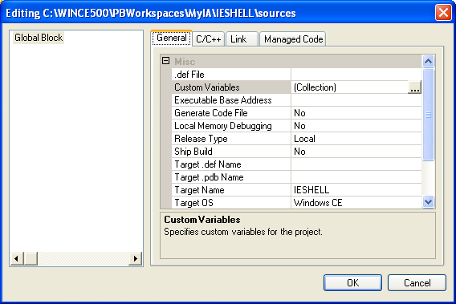
    - Click on the C/C++ Tab and scroll down to the Include Directories item.
    - Enter (as one line):
$(_WINCEROOT)\PUBLIC\IE\SDK\INC; $(_WINCEROOT)\PUBLIC\COMMON\OAK\INC;

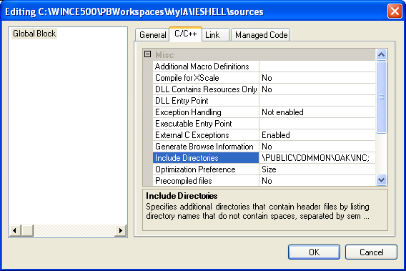
    - Click OK.
    - The SOURCES file can also be edited directly as text.
  - Right-click IESHELL and select Open, or
  - Select IESHELL and use the Project and then Open item from the main menu.
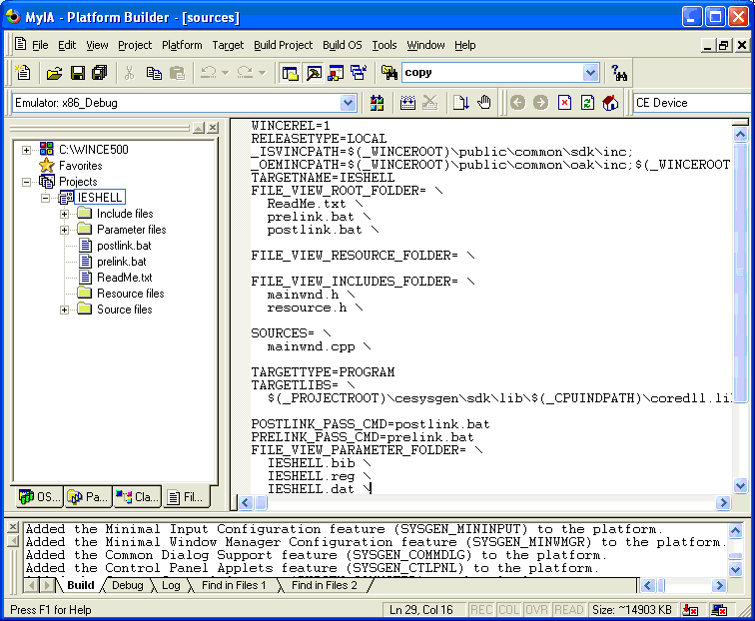
    - Scroll to the end of the file and verify that the INCLUDES section has been added.
    - Add in the extra TARGETLIBS.
TARGETTYPE=PROGRAM
TARGETLIBS= \
$(_PROJECTROOT)\cesysgen\sdk\lib\$(_CPUINDPATH)\coredll.lib \
$(_PROJECTROOT)\cesysgen\sdk\lib\$(_CPUINDPATH)\wininet.lib \
$(_PROJECTROOT)\cesysgen\sdk\lib\$(_CPUINDPATH)\commctrl.lib \
$(_PROJECTROOT)\cesysgen\sdk\lib\$(_CPUINDPATH)\uuid.lib \
$(_PROJECTROOT)\cesysgen\sdk\lib\$(_CPUINDPATH)\ole32.lib \
$(_PROJECTROOT)\cesysgen\sdk\lib\$(_CPUINDPATH)\oleaut32.lib \

POSTLINK_PASS_CMD=postlink.bat
PRELINK_PASS_CMD=prelink.bat

We determined what target libs were required by examining WINCE500\PUBLIC\IE\CESYSGEN\makefile. Search for iesimple and you will see that it is built using $(OLELIBS), $(WININETLIB) and $(CCLIB). Further searching of the file for these macros reveals the underlying lib names required.
Note

    - Save the changes by selecting File and then Save from the main menu.
    - Select Build Project and then Build Current Project and verify that it builds with no errors.
    - Rebuild the OS image (Build OS and then Make Run-Time Image).
    - Download the image (Target and then Attach Device).
    - On the Emulator, click the Start Menu, select Run…, enter ieshell and click OK.
    - The IEShell application should start. If the lab PC is connected to the internet and configured correctly, you should see the msn.com home page.

Autostart (autoexec) custom program in WinCE

The goal here is to build a Windows CE image that will launch an embedded application as the shell of system.

- Open the file NewShell.Reg and add the following lines:
[HKEY_LOCAL_MACHINE\init]
"Launch90"="IEshell.exe"
"Depend90"=hex:14,00,1E,00
By defining these keys, Windows CE will launch the process IEshell.exe after the process defined by the entries Launch20 (device.exe) and Launch30 (gwes.exe). I.e. IEshell.exe requires that device.exe and gwes.exe are initiated.

© Microsoft corp.

Lab II
at Microsoft Italia (Milano) 02-11-2005
by Marco Cavallini - Koan s.a.s.
Bergamo – ITALIA
www.koansoftware.com

